Cloud Front lab

Check VPC setting

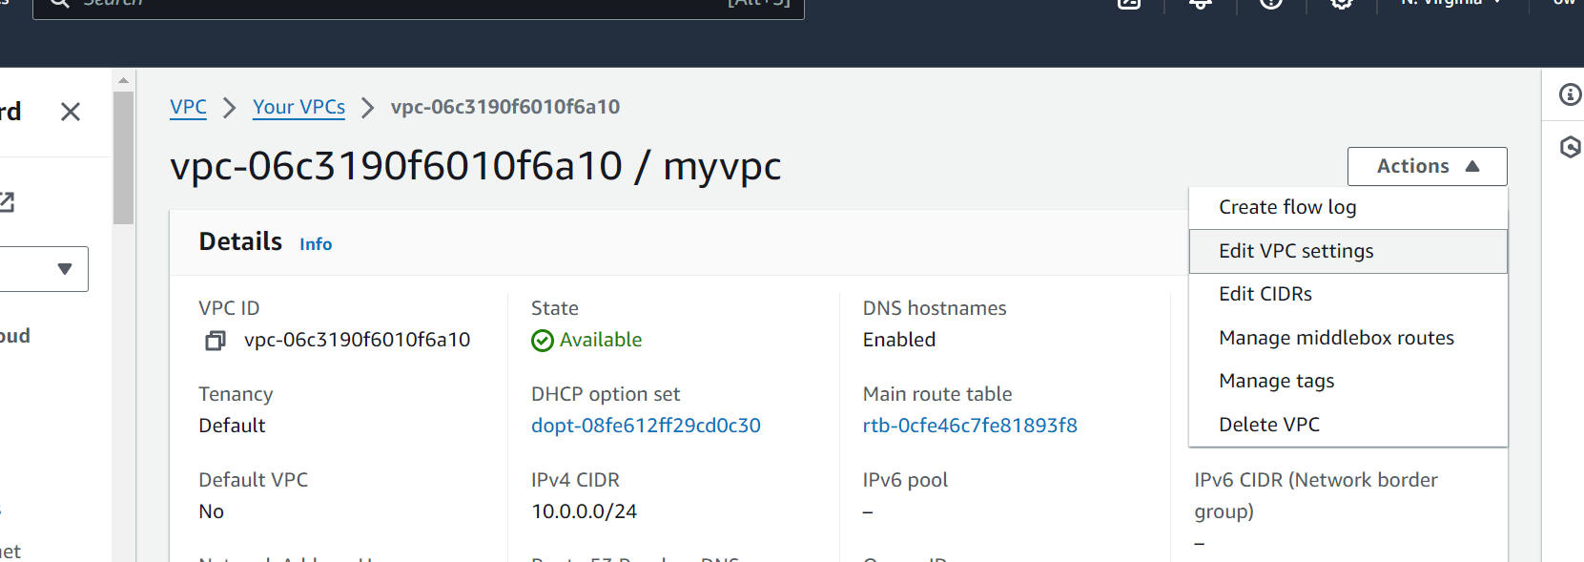

Enable DNS hostname

1. Launch the EC2 instance
2. Connect through putty
3. Install webserver

sudo apt update

sudo apt install apache2

1. EC2 dashboard, check security group
2. Edit the inbound rule

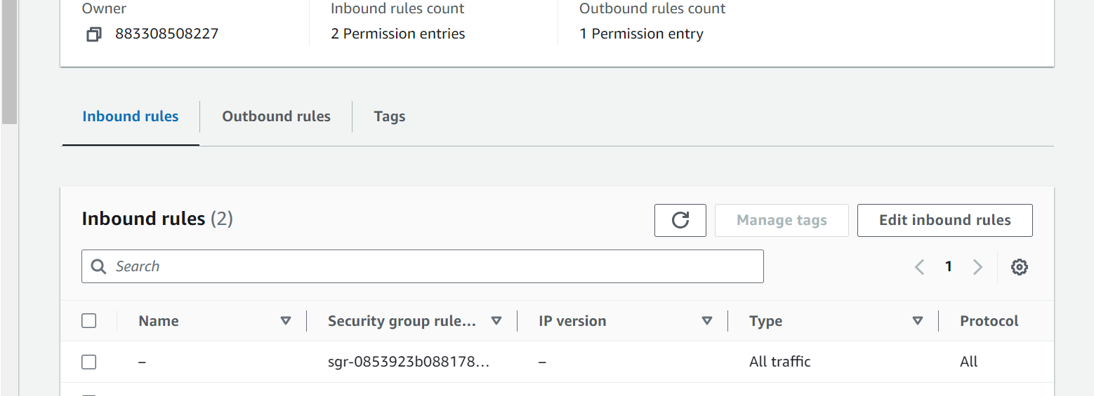

1. Add http rule

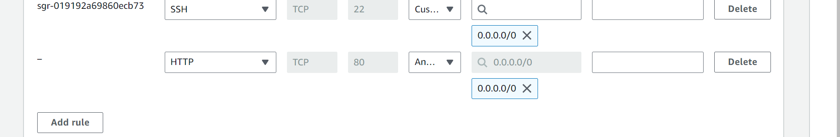

1. Get the vm name (public dns name)

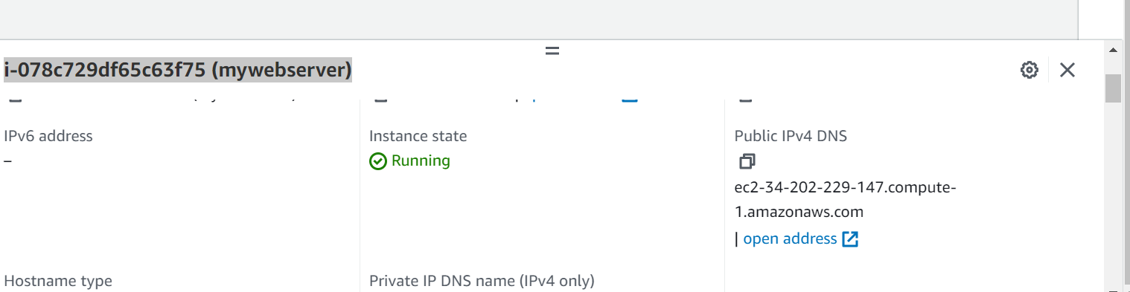

8)open in browser

http://<publicip>/index.html

8)Select Cloud front

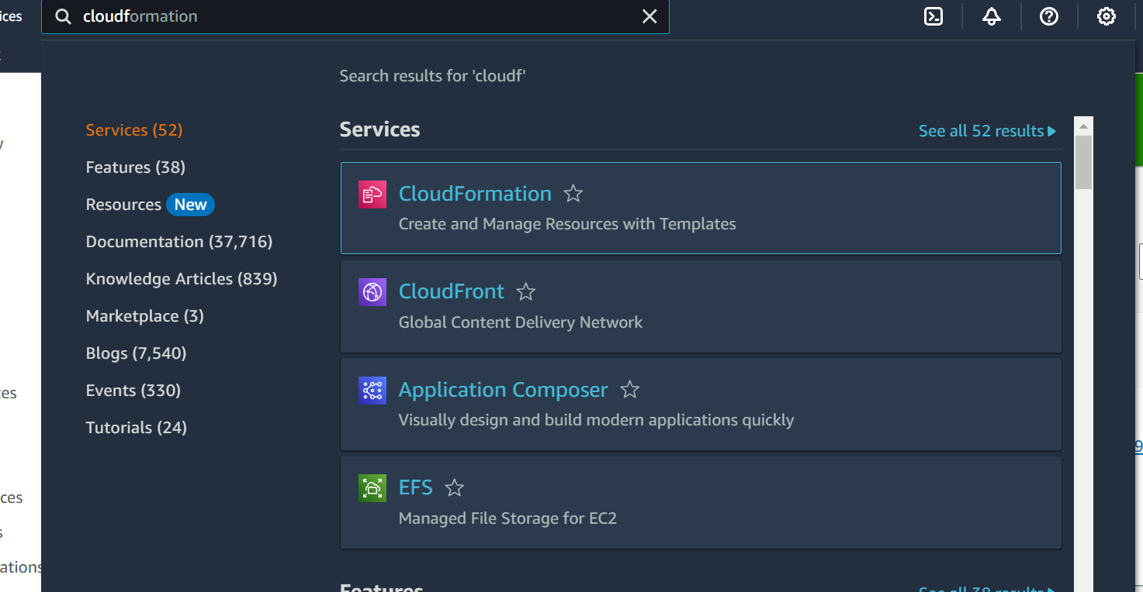

9)Create Distribution

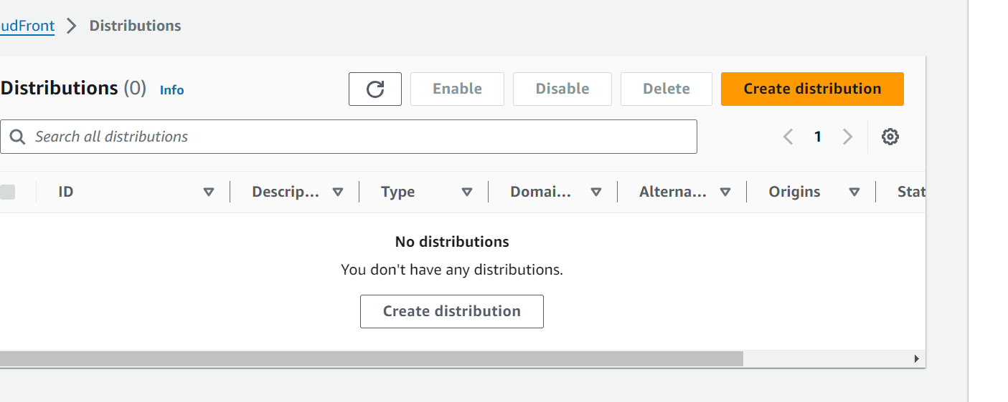

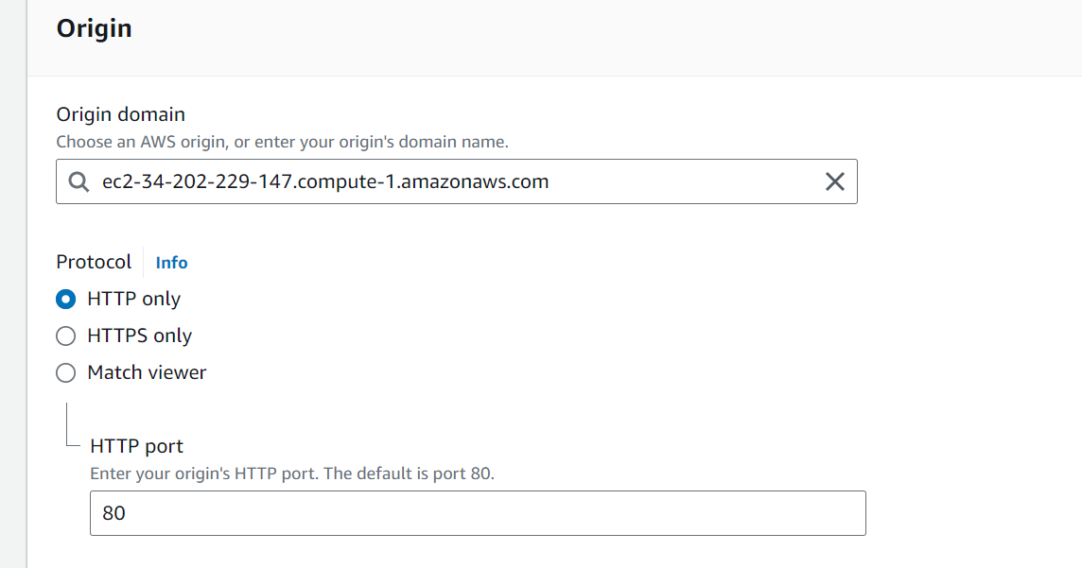

Provide the path

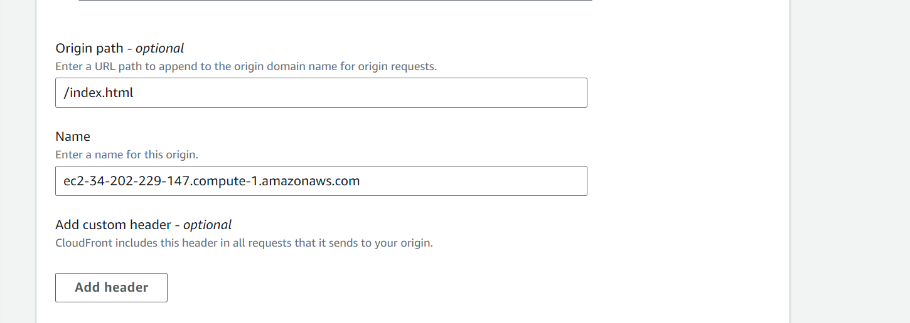

WAF disable

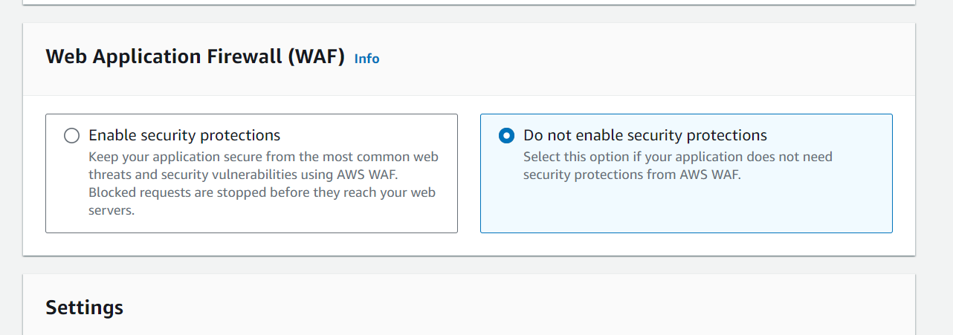

Create staging distribution

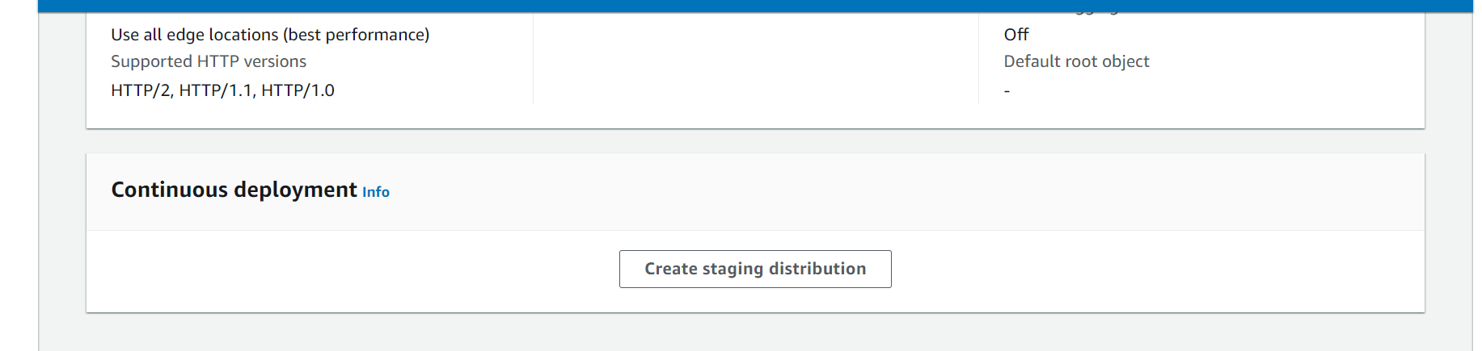

Deploying

